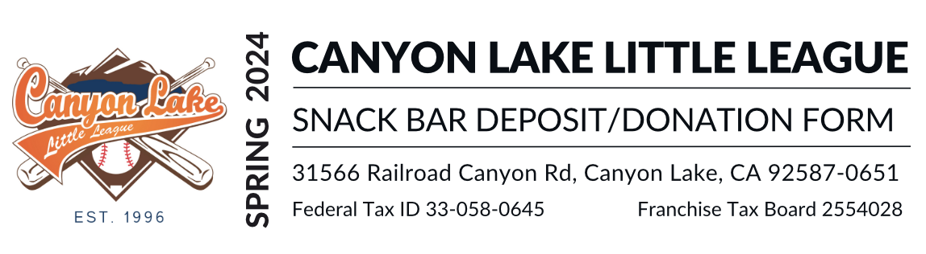A $100 snack bar shift promissory deposit check (one deposit check per player in the league) is required prior to your child having their uniform issued. Our policy is for checks only, with no cash, cashiers checks, money orders, or credit cards accepted. This check is not deposited, but held as a promise to work the snack bar shift assigned to you. Once you have completed your assigned shift, the check is shredded. The check will be cashed immediately if you fail to have approved coverage for your shift(s), do not work full shift or do not show up.
This form is for you requesting an exception to this policy. Cash will be accepted only if there is no option by the player's family to provide a deposit check. If cash is given as your snack bar deposit, it is YOUR responsibility to request your refund from the snack bar manager within 48 hours of our final game of the season. ANY CASH Deposit not requested in that time will be forfeited and is considered a donation to Canyon Lake Little League it will not be refunded or rolled to the next season. By submitting a cash deposit with this form, you are agreeing to these terms outlined above. Your cash deposit will be immediately forfeited (donated to CLLL) if you fail to have approved coverage for your shift(s), do not work full shift or do not show up.

Player/Contact Information
Parent/Guardian (First and Last) | Player (First and Last)
Street Address | Division and Team Name
City, State and Zip | Phone

Donation Description
Cash Received by CLLL Board Member: Last Name and Initial | Date:
Notes: Including additional players names, total received, etc.

Contact Information for Refund Requests:
Contact Name:  Snack Bar Manager | Cell: (123) 456-7890  Email: CanyonLakeLittleLeague@gmail.com

